CSC500 Module 7: Critical Thinking Assignment

Python dictionaries to store course details such as room numbers, instructors, and meeting times with Input Validation
Pseudocode
START
Create dictionary room_numbers with course_codes and room values
Create dictionary instructors with course_codes and instructor names
Create dictionary meeting_times with course_codes and meeting times
LOOP
Ask user to enter course number
Convert input to uppercase if provided in lowercase and remove spaces
IF input is empty
Display "Input cannot be empty"
CONTINUE LOOP
IF input format is invalid
Display "Invalid format"
CONTINUE LOOP
IF course not in room_numbers
Display "Course not found"
CONTINUE LOOP
ELSE
EXIT LOOP
END LOOP
Display course details:
Room number
Instructor
Meeting time
END
Source Code
""""
Assignment 7
Course Details
Author: Shadab
"""
# Python code using Dictionaries to store Course Details
# user provides Inputs at Runtime and also validations for inputs
room_numbers = {
"CSC101" : "3004",
"CSC102" : "4501",
"CSC103" : "6755",
"NET110" : "1244",
"COM241" : "1411"
}
instructors = {
"CSC101" : "Haynes",
"CSC102" : "Alvarado",
"CSC103" : "Rich",
"NET110" : "Burke",
"COM241" : "Lee"
}
meeting_times = {
"CSC101" : "8:00 a.m.",
"CSC102" : "9:00 a.m.",
"CSC103" : "10:00 a.m.",
"NET110" : "11:00 a.m.",
"COM241" : "1:00 p.m."
}
# Input Validation
while True:
course_code = input("Enter course number: ").strip().upper()
if course_code == "":
print("Warning!! Input cannot be empty. Input valid value.")
continue
if not (course_code[:3].isalpha() and course_code[3:].isdigit()):
print("Warning!! Invalid course code format. Input a valid course code format like CSC101.")
continue
if course_code not in room_numbers:
print("Course not found. Input a valid course code.")
continue
break
# Display Results
print("\n************ Course Details *************\n")
print("Course Number Entered:", course_code)
print("Room Number:", room_numbers[course_code])
print("Instructor:", instructors[course_code])
print("Meeting Time:", meeting_times[course_code])
print('\n*****************************************\n')
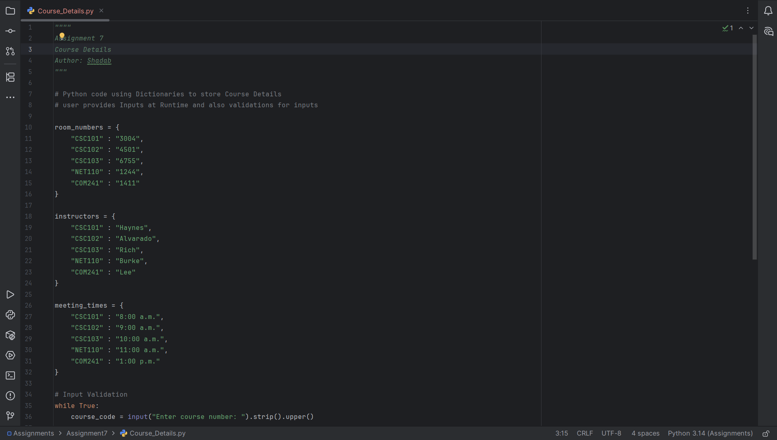

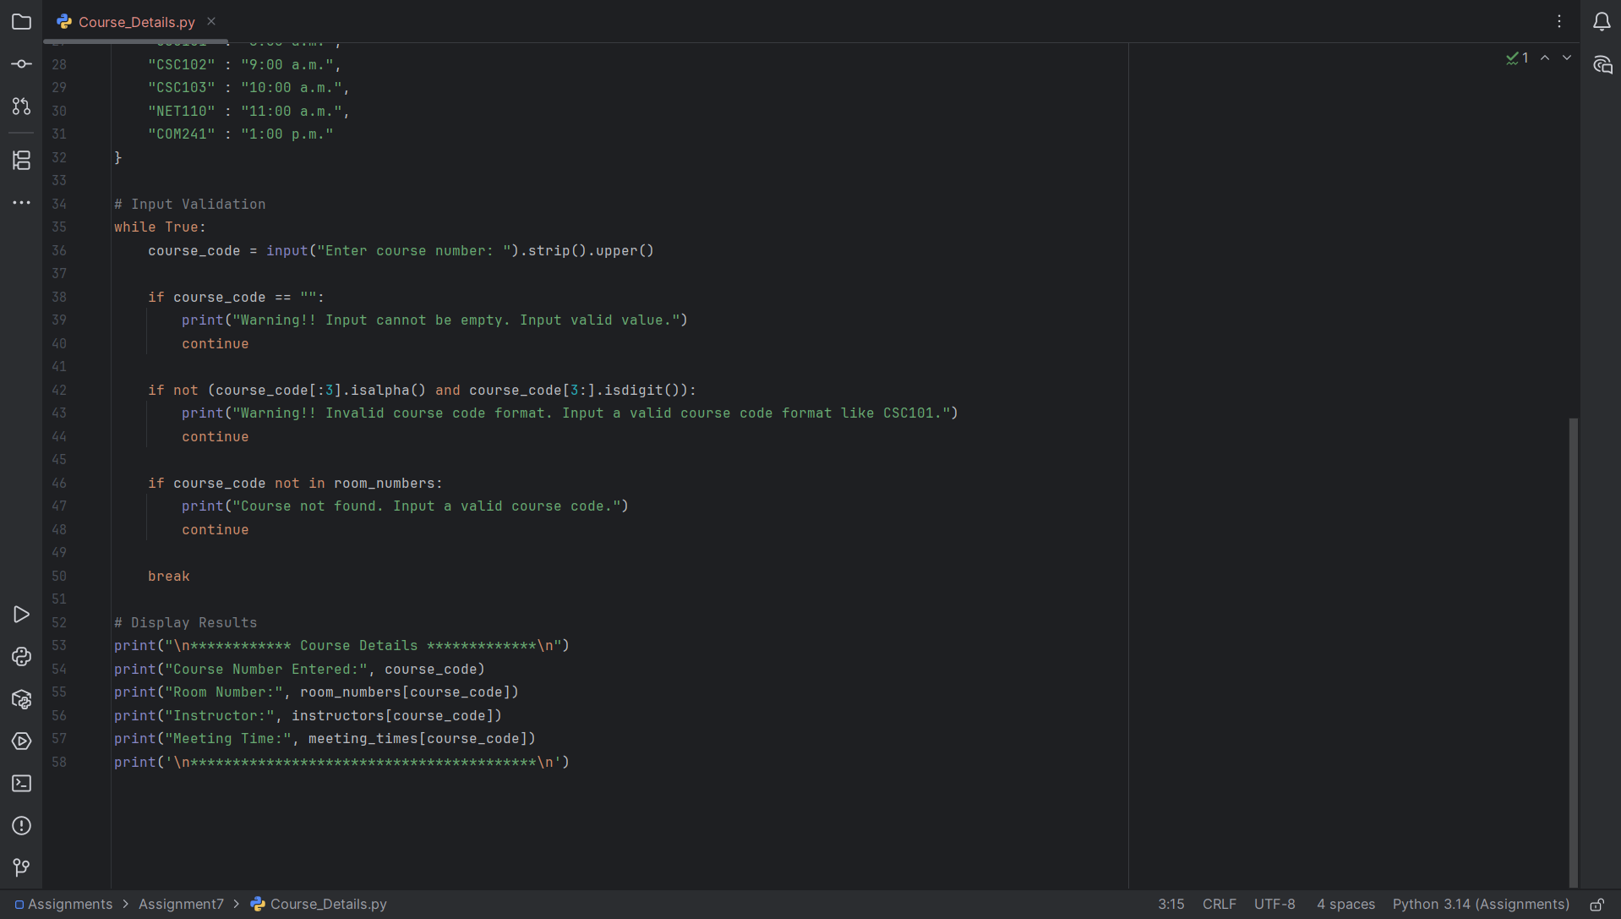

Program Execution Screenshots
Validation 1: When input is empty for Course Number
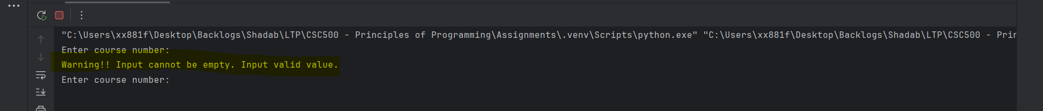

Validation 2: When input provided for Course Number is strings or special characters
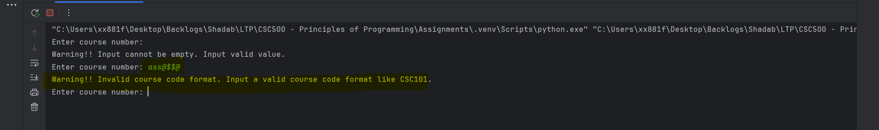

Validation 3: When Course Number provided is not in the dictionary
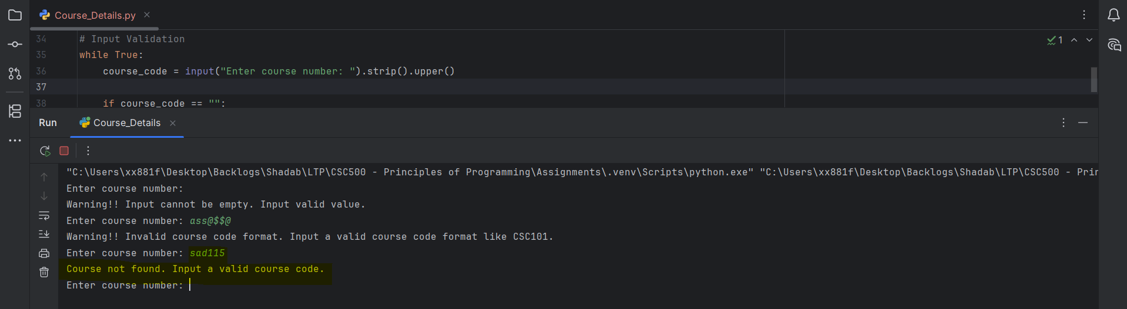

Validation 8: When Valid Course Number is provided
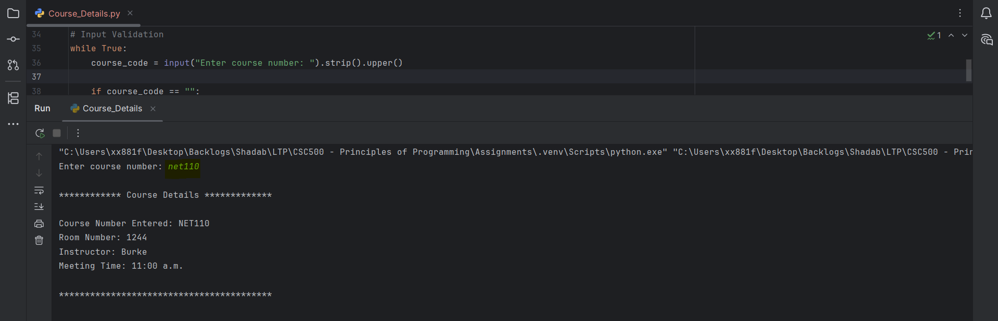

Part 3 – Git Repository
Created a Git-Hub Account with Repository name as “CSC500---Principles-of-Programming”
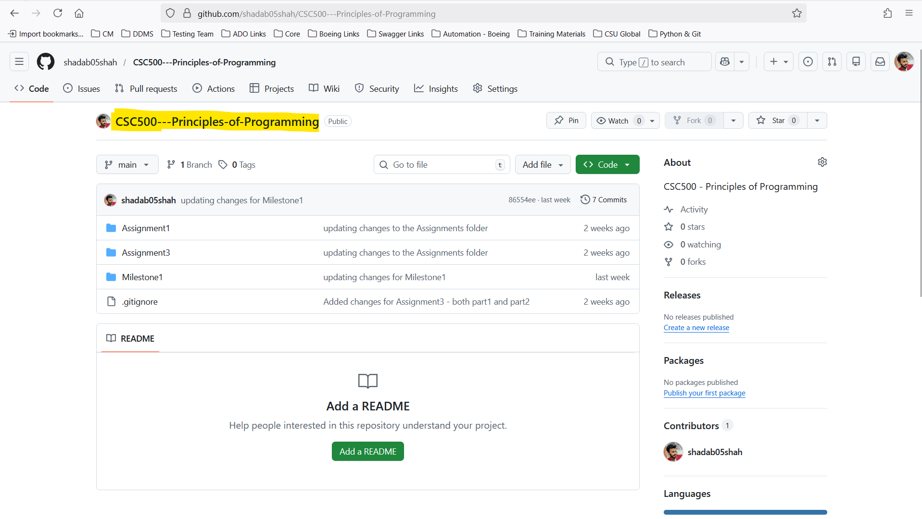

Main Project Folder Structure in Local
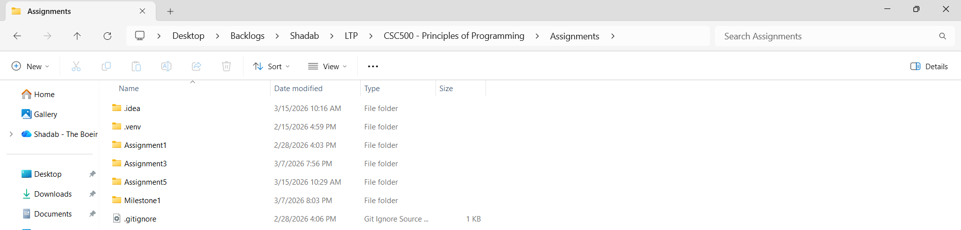

Initialize Git using “git status”
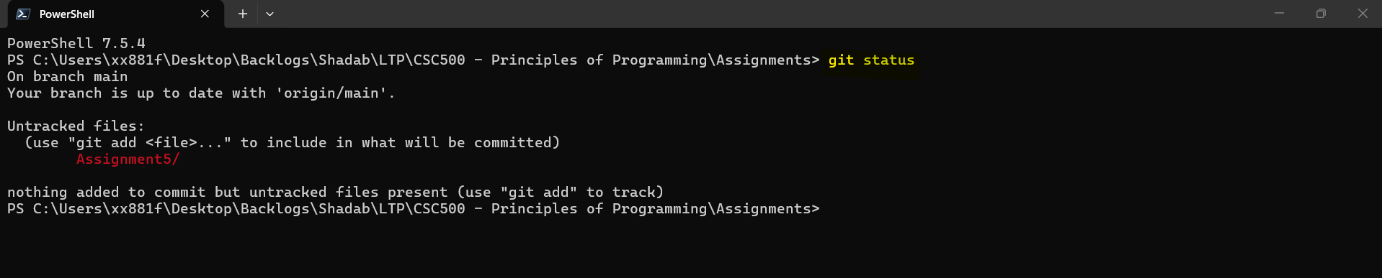

Adding Assignment5 folder
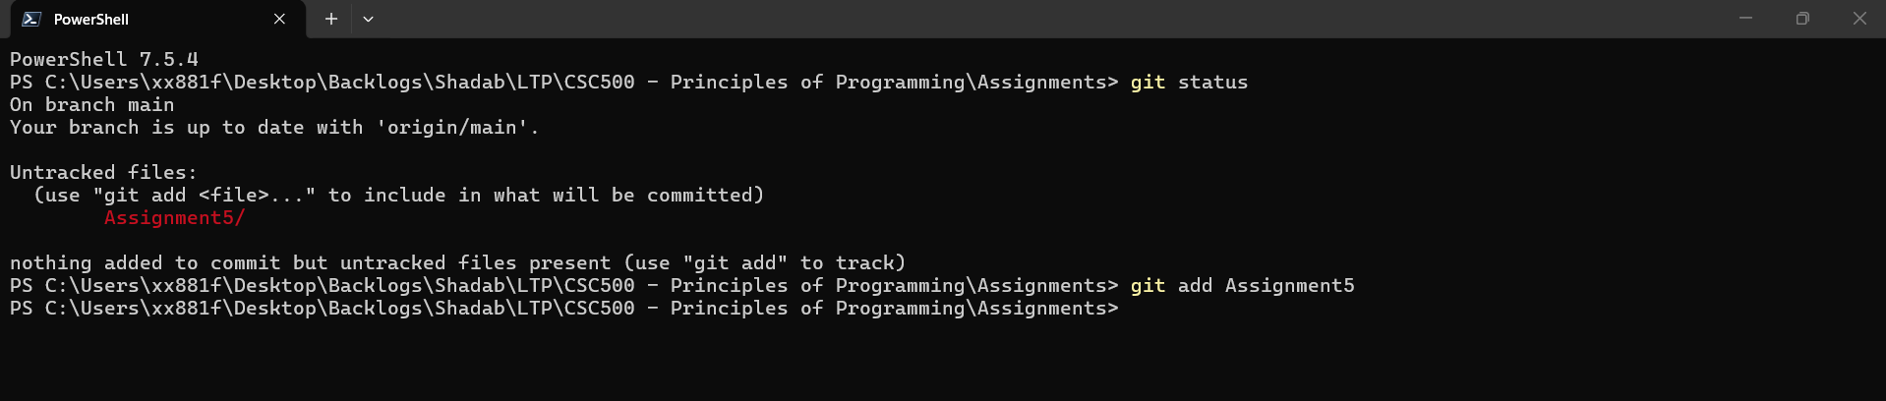

Commit Changes
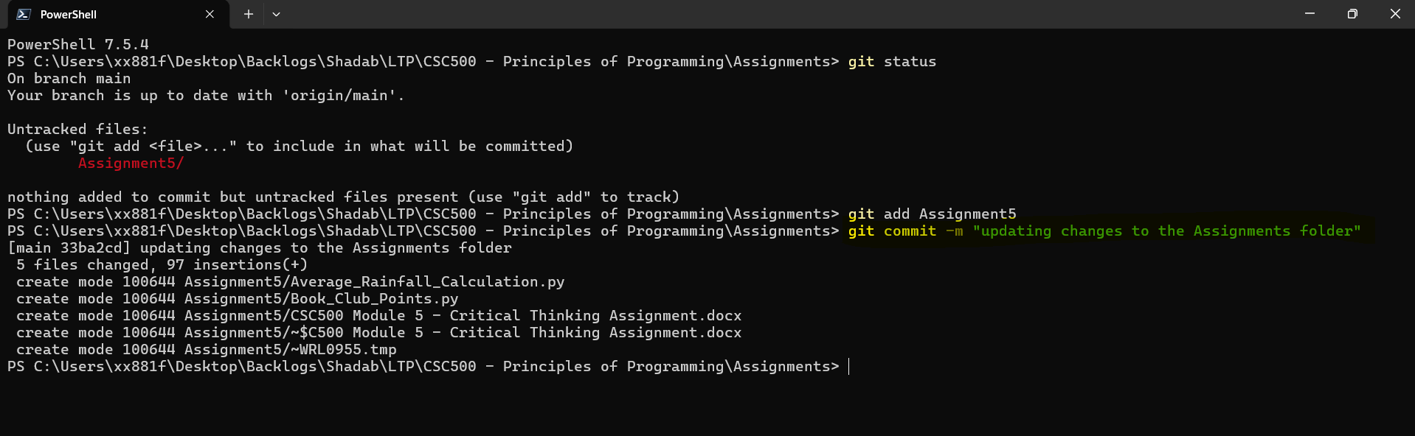

Pushing the Changes
git push origin main
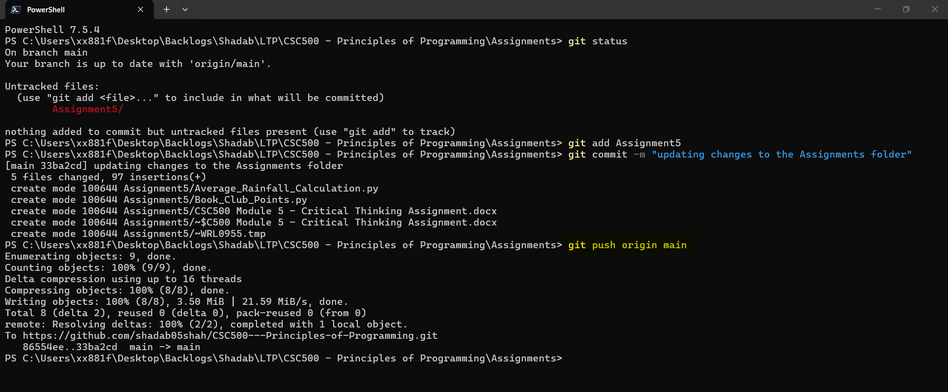

Checking Status
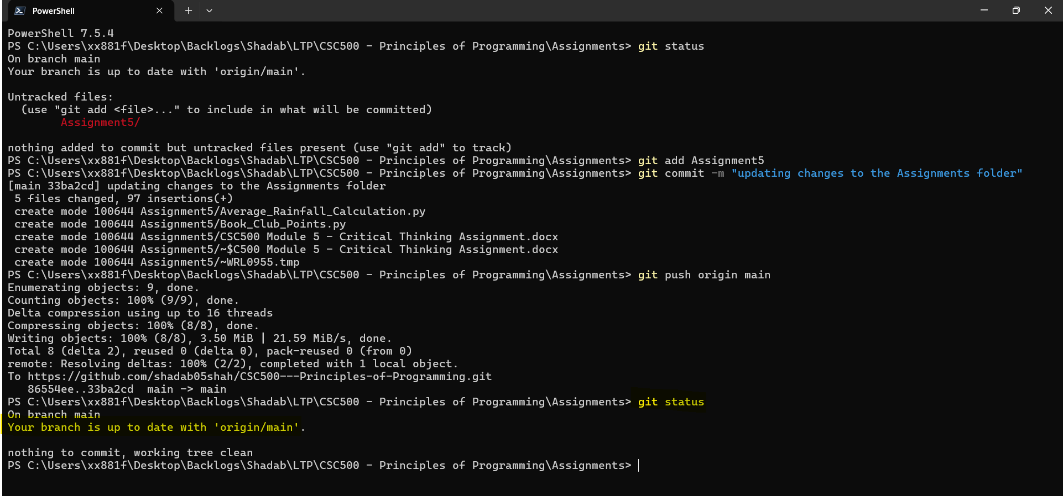

In Git-Hub repo page
